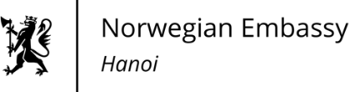
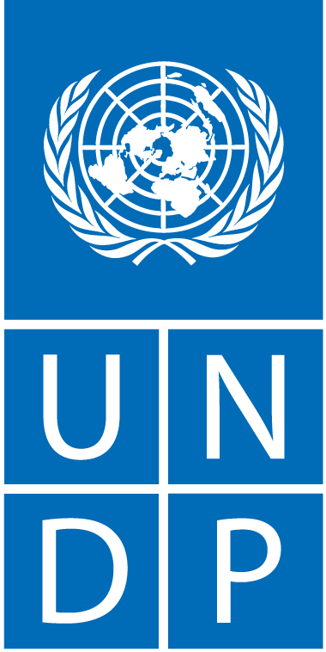

PRESS RELEASE
Unlocking the Potential of Offshore Wind Energy through Sustainable Marine Spatial Planning: Insights from Experts

Ha Noi, 20 April 2023 – The Norwegian Embassy in Ha Noi and the United Nations Development Programme (UNDP), in collaboration with the National Assembly's Committee on Science, Technology and Environment, organized a workshop entitled "Viet Nam's Marine Spatial Planning and Offshore Wind Energy" today.
At the workshop, international experiences were shared, and next steps for marine spatial planning (MSP) and offshore wind power development in Viet Nam were discussed. Experts from Norway and UK, among others, shared valuable insights and recommendations on sustainable ocean planning, zoning, offshore wind energy, and assessment of and qualification criteria for sea areas for offshore wind.
The workshop highlighted the crucial role of MSP, which will identify feasible sites for offshore wind energy projects, in the growth of the blue economy by catalyzing innovative technologies, responding to climate change impacts and fostering the energy transition.
Viet Nam is at a relatively early stage in the process of formulating both its coastal zone planning and sustainable management of resources document, and its MSP document.
According to Dr. Ta Dinh Thi, Deputy Chair of the National Assembly’s Committee on Science, Technology and Environment, “Developing renewable energy is a major policy for the Party, the National Assembly, and the Government of Viet Nam, for whom offshore wind power is identified as one of the breakthrough solutions for energy transformation and national energy security. It is also closely related to marine spatial planning, especially for identifying potential marine areas and suitable zoning for offshore wind power development."
"The National Assembly has also recently issued Resolution No. 582/NQ-UBTVQH15 dated August 29, 2022, of the National Assembly Standing Committee on the establishment of a thematic monitoring team for the implementation of policies and laws on energy development for 2016-2021, as well as Plan No. 355/KH-Monitoring Delegation dated October 28, 2022, on thematic monitoring,” he said.
Ms. Ramla Khalidi, UNDP Resident Representative in Viet Nam, highlighted that "The marine spatial planning is essential for unlocking the tremendous potential of offshore wind power development for Viet Nam, contributing to the achievement of the Sustainable Development Goals and climate change commitments made at COP26, including achieving net zero emissions by 2050."
"Marine spatial planning should be seen as a continuous process rather than a single fixed product. As such, we must not seek to develop a single, perfect and all-encompassing document at this stage," she added. "It is essential that the development and approval of the Marine Spatial Plan, as well as the definition of the sites for offshore wind power development, is done in an open, consultative and inclusive process. Engagement of all stakeholders, especially local communities will be important, to ensure equitable sharing of benefits and the protection of vulnerable groups."
The flagship publication "Blue Economy Scenarios for Viet Nam," a comprehensive report released by UNDP and the Viet Nam Administration of Seas and Islands (VASI) under the Ministry of Natural Resources and Environment in May 2022, examines the potential behind sustainably developing Viet Nam’s marine economy. It concluded that if a blue scenario is applied, it is estimated that the GDP of Viet Nam’s marine economic sectors will be 34% (or 23.5 billion USD) higher; and GNI per capita in these sectors almost 78% (or 7,100 USD) higher compared to the business-as-usual scenario in 2030.
"As a long-standing partner of Viet Nam, we are proud to support this workshop. Norway is committed to combating climate change and to develop sustainable ocean economy. As a leading ocean nation with prominent marine industries, we see that emerging industries like offshore wind power have a vital role to play” said H.E. Ms. Hilde Solbakken, Norwegian Ambassador to Viet Nam.
Ambassador Solbakken emphasized "An effective approach to oceans management is and has been a very helpful tool to Norway. We believe a marine spatial plan would ensure the sustainable ocean management, which is essential for achieving our shared vision of a green, resilient, and prosperous future. By sharing and learning from each other we can ensure all industries would benefit from the ocean while marine ecosystems and biological diversity are preserved. We are committed to working with our partners in Viet Nam including the UNDP and key Ministries and authorities of Viet Nam to promote sustainable blue growth, protect the marine environment, and support the country's energy transition”.
In attendance were key stakeholders in the area of MSP in Viet Nam, including VASI, the Electricity and Renewable Energy Authority, Petro Viet Nam, GIZ, the World Bank and the Norway-based energy company Equinor, along with representatives from embassies, provincial authorities, international organizations and experts, and the private sector.
By providing a framework for decision-making and stakeholder engagement, MSP is expected to further ensure that renewable energy, and especially offshore wind power, is developed in a way that is socially and environmentally sustainable, while also contributing to Viet Nam’s rising energy needs.

For more information, please contact:

Phan Huong Giang
Media & Communications Analyst,
UNDP Viet Nam
phan.huong.giang@undp.org
Tel: 0948 466 688

Nguyen Thi Kim Thanh
Information and Communication Adviser,
Norwegian Embassy in Ha Noi
Email: Thi.kim.thanh.nguyen@mfa.no
Tel: 0904 637 298

