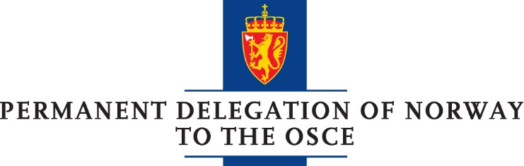

STATEMENT IN REPLY TO THE BRIEFINGS GIVEN BY
AMBASSADORS SAJDIK AND APAKAN

Delivered by Minister Counsellor Henning Hj. Johansen at the Permanent Council
Vienna, 8 February 2018

CHECK AGAINST DELIVERY

Mr Chair,
We join other delegations in welcoming ambassador Sajdik and ambassador Apakan to the Permanent Council. We reiterate our full support to the SMM and the Trilateral Contact Group.
This Council has received first-hand information on the conflict situation for almost four years now. Vast resources and political efforts are being spent to make headway. Still, progress on the ground is negligible. We find the regular reports on new death tolls and casualties appalling and most worrying. Putting an end to the conflict would save thousands of civilians and allow this part of Ukraine to prosper and restore security and stability for the benefit of us all.
We deeply regret the lack of political will of the parties that too long has prevailed. We reiterate our call to the parties, including the Russian Federation, to respect the ceasefire and comply with the provisions of Minsk-agreements.
Mr Chair,
The SMM is carrying out a commendable job in gathering and disseminating factual and objective independent information from the conflict zone. It is with great concern we repeatedly see their mandate being ignored, with the result that the monitors continue to face threats, intimidations and violation of their security.
The previous week is no exception. On 2 February, in the vicinity of separatist controlled Yasinuvata, shots from heavy machine guns and small arms came unacceptably close to six monitors. On February 3, while conducting a mini-UAV flight in a government-controlled area west of Donetsk, shots were fired, presumably targeting the UAV. We find this deplorable and completely unacceptable.
We urge all sides, including the Russian Federation, to live up to their obligations, to respect the mandate of the SMM and bring perpetrators to justice. We urge the Russian Federation to return to the JCCC. We appreciate that SMM has found practical solutions to ensure temporary ceasefire agreements and security guarantees for necessary work near the conflict line. However, we want to underline that any such practical coordination does not change our position on the legality of the de-facto “authorities” in the so-called LNR and DNR.
Mr Chair,
The situation in the Russian occupied Crimea remains a great concern. We call upon the Russian Federation to fully restore the rights of Crimean Tatars and Ukrainian citizens in general, and avoid any indiscriminate actions. Norway urges the Russian authorities to give international organisations and NGOs full access to Crimea immediately.
In conclusion, Norway would like, once again, to reiterate our unwavering support to the sovereignty and territorial integrity of Ukraine within its internationally recognized borders.
Thank you.

