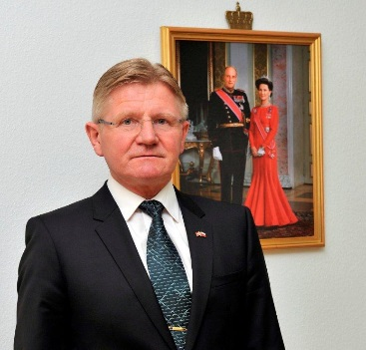
CURRICULUM VITAE
Ambassador Karsten Klepsvik

2018 – Ambassador of Norway to Lithuania

2015 - : Norway`s permanent representative to the International Committee - Auschwitz-Birkenau Foundation

2013 – 2018: Ambassador of Norway to Poland

2005 - 2013: Polar Affairs Advisor for Norwegian Minister of Foreign Affairs, Norwegian Commissioner/Ambassador to the International Whaling Commission, Norwegian Senior Arctic Official in the Ministry of Foreign Affairs (MFA).

2006 -2009 : Chair Senior Arctic Officials of the Arctic Council

2001 - 2005: Press Spokesman for the Norwegian Minister of Foreign Affairs.

1999 - 2001: Director General, MFA, Division for human rights, humanitarian assistance and democracy building.

1995 - 1999: Deputy Head of Mission, Norwegian Embassy in Washington, D.C.

1993 - 1995: Director General/Ambassador and Barents Affairs Advisor, MFA.

1991 - 1993: Managing director Federation of Norwegian Fish Processing Industry in the Norwegian Federation of Businesses

1990 - 1993: Director General, Division of Resources, Norwegian Ministry of Fisheries.

1989 -1990: Head of International Section, Min. of Fisheries.

1986 - 1989: Embassy Secretary for political Affairs, Norwegian Embassy in Washington, D.C.

1983 - 1986: Embassy Secretary for Economic & Political Affairs, Norwegian Embassy in Manila.

1981 - 1983: Trainee in the Ministry of Foreign Affairs, Oslo

Education (from University in Bergen):
Cand. polit in political science and international economics.
Basic course in psychology
Born August 4, 1952

