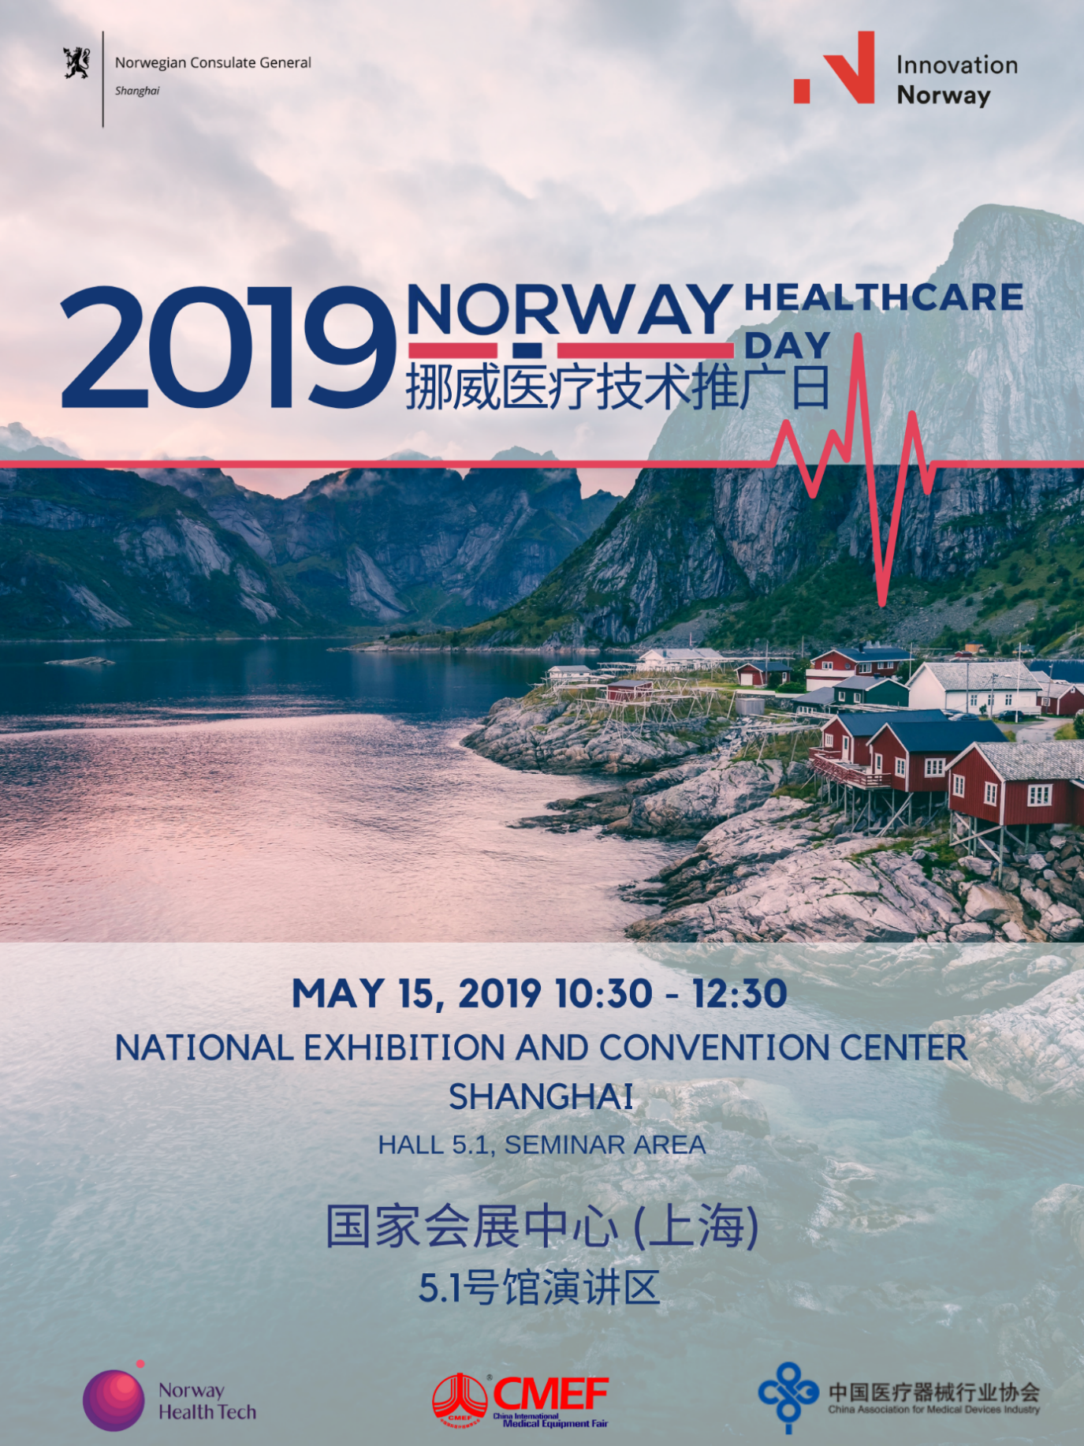

[活动邀请]2019中国国际医疗器械博览会挪威推广日| 5月15日 | 上海
Invitation - Norway Day - China International Medical Equipment Fair in Shanghai 2019.15.05
Norway is one of the most developed countries in the world. Our per capita GDP and human development index has been ranked among the top three in the world for many years, with high medical level and social welfare.
Our high-quality universal healthcare system is one of the things that make the Norwegian model unique. For more than 70 years, Norway has had a strong focus on national health care development. This is why Norway scores overall very high on different global rankings in healthcare performance.
In Norway, we work to make technological solutions that give our citizens better and richer lives. The new and rapidly growing Norwegian health industry (growth of 10-12 per cent per year) is developing new and cost-saving solutions for the Norwegian health services, while at the same time building a growing export industry.
The Norwegian healthcare industry provides a great number of products and solutions for the market both at home and abroad, many of which are among the best in the global healthcare industry. Norway is leading particularly in the fields of medical technology, such as ultrasound imaging, cancer treatment, neuroscience etc. The annual output value of the health technology industry is 37 billion NOK.
Norway Health Tech, DNV GL, Laerdal, Dignio, Sero will show you their innovative medical products and solutions in this event.
挪威是全球最发达的国家之一，人均GDP和人类发展指数连续多年排名世界前三，具有较高的医疗水平和社会福利。
我们高品质的全民医疗保健制度是挪威模式与众不同的因素之一。 70多年来， 挪威始终高度重视国家医疗保健的发展，这也是为什么挪威能在不同的全球医疗保健质量评比中总是名列前茅的原因。
在挪威， 我们致力于通过制定技术解决方案， 为我们的人民提供更优质更丰富的生活。新兴并快速增长的挪威医疗产业（每年的增长率为10-12%）， 不但为挪威的医疗服务开发出新型高效的解决方案，同时也打造了一个不断增长的出口行业。
挪威医疗保健行业为国内外市场提供了大量的产品和解决方案，其中很多都是全球医疗保健行业的佼佼者。特别在超声影像、肿瘤治疗、神经科学等医疗技术领域占据领先地位，医疗健康技术产业年产值370亿克朗。
此次参加挪威技术推广日的Norway Health Tech，DNV GL、Laerdal, Dignio, Sero将在本次活动中为您展示具有创新意义的医疗产品及解决方案。

AGENDA 会议日程
10:00-10:30 | REGISTRATION  注册
10:30-10:40 | WELCOME SPEECHES  欢迎致辞  - Mr. Knut Sørlie, Commercial Counsellor of Royal Norwegian Embassy in Beijing  索黎先生，挪威王国驻华大使馆商务参赞  - Mr. Ding Chuanjun, Project Director of Medical BU，Reed Sinopharm  丁传军先生，医疗器械项目总监，国药励展
10:40-10:55 | THE NORWEGIAN E-HEALTH PERSPECTIVE AND MARKET OBSERVATIONS  挪威的电子医疗前景和市场观察  Ms. Katrine Haukenes, Acting Consul General, Norwegian Consulate General in Shanghai, on behalf of Norwegian Directorate for E-health  郝美琳女士，代总领事，挪威王国驻上海总领事馆， 代表挪威电子医疗局发言
10:55-11:10 | INVESTMENT OPPORTUNITIES OF LIFESCIENCES AND MEDTECH IN NORWAY  挪威生命科学和医疗技术领域的投资机遇  Ms. Hanne Mette Dyrlie Kristensen, Special Advisor of Invest in Norway  挪威投资局特别顾问
11:10-11:25 | THE OPPORTUNITIES AND CHALLENGES FOR NORWAY-CHINA MEDTECH COOPERATION  中挪医疗技术合作的机遇和挑战  Ms. Shan Xu, Secretary General of China Association of Medical Devices Industry 徐珊女士，中国医疗器械行业协会秘书长
11:25-11:40 | THE NORWEGIAN HEALTH INDUSTRY – FAST GROWING THROUGH COLLABORATION IN THE HEALTH INNOVATION ECOSYSTEM  挪威健康产业- 创新生态系统合作推动产业快速发展  Ms. Kathrine Myhre, CEO of Norway Health Tech  挪威医疗技术集群CEO
11:40-11:50 | THIRD PARTY ACCREDITATION TO ASSURE THE QUALITY AND SAFETY OF HEALTHCARE PROVIDERS  第三方认证助力医疗机构的质量和安全  Mr. Huijie Bo, Director General for DNV GL Greater China, Healthcare  薄会杰先生，DNV GL医疗中国区总经理
11:50-12:00 | APPLICATION OF AI AND BIG DATA IN FIRST AID  AI 和大数据在急救培训领域的应用  Ms. Lanlan Jiang, Product Manager of Laerdal Medical  江兰兰女士，挪度医疗复苏产品经理
12:00-12:10 | THE IMPORTANCE OF HIGHLY COMMUTABLE CONTROL MATERIALS TO SECURE RELIABLE LABORATORY RESULTS  高互换性质控品对确保可靠的实验室结果的重要性  Ms. Cangsong Liu, Country Manager, SERO BioScience & Technology (Beijing) Co.,Ltd  刘苍松女士，中国区经理， 塞若生物科技（北京）有限公司
12:10-12:20 | NORWAY DIGNIO INTERCONNECTED CHRONIC DISEASE MANAGEMENT SYSTEM  挪威迪格尼奥互联慢病管理系统  Ms. Huijia Liu Sollid , China Region Manager, Dignio AS  刘惠佳女士，迪格尼奥公司中国区经理
12:20-12:25 | CLOSING REMARKS  闭幕致辞  Ms. Katrine Haukenes, Acting Consul General of Royal Norwegian Consulate General Shanghai  郝美琳女士, 代总领事
THE NORWEGIAN DIRECTORATE OF E-HEALTH 挪威电子医疗局
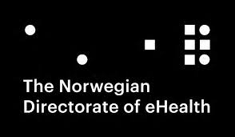
Established on January 1st, 2016, The Norwegian Directorate of eHealth (NDE) is a professional and governmental body, a sub-ordinate institution of our Ministry of Health and Care Services.The Norwegian Directorate of eHealth will implement the national policy on eHealth, establish the requisite standards, and administrate the use of eHealth methodology nation-wide.
Our two principal responsibilities
1. National steering and coordination of eHealth through close cooperation with regional health authorities, local authorities, technical organisations, and other interested parties.
2. Develop and administrate digital solutions that will improve and simplify our health and care sector.
Our Social Commitment
1. We will contribute to making our health and care sector a holistic and knowledge-based endeavour, which utilises the new technological possibilities and involves the people in order to achieve better public health, better results from the health and care sector, and better use of the resources.
2. We will motivate and stimulate the development of better eHealth solutions.
挪威电子医疗局成立于2016年的1月1日。它是挪威卫生和护理部下属的专业机构和政府部门。挪威医疗局实施国家电子医疗政策， 建立必要的标准， 并在全国范围内管理电子医疗方法的使用。
我们的两大主要责任
1. 通过与区域卫生当局、地方政府、技术组织及其它相关方的紧密合作，指导并协调电子医疗的发展。
2. 发展并管理数字解决方案， 改善和精简我们的卫生护理部门。
我们的社会责任
1. 我们致力于提供全面的以知识为基础的卫生与护理服务， 利用新的可行性技术并提高人民的参与度， 以实现更好的公共卫生，更合理地利用资源。
2. 我们将推动并促进发展更好的电子医疗解决方案。
NORWAY HEALTH TECH 挪威医疗技术集群
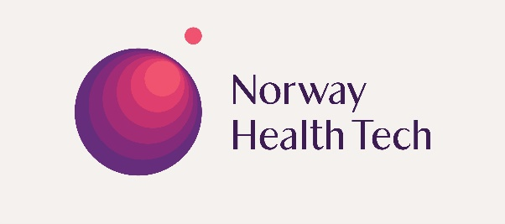
Norway Health Tech has a vision of making Norway the world’s best arena for health innovation. We are a non-for-profit member organization with close to 270 members in our base – representing the full value chain of healthcare. We address all areas of human health – with an eye for technology.
We aim to create sustainable solutions for the greatest global health challenges, by strengthening competitiveness and facilitating strong growth in the Norwegian health industry, and expanding international cooperation.
挪威医疗技术集群的愿景是使挪威成为全球健康创新的最佳舞台。我们是一个非盈利性组织，拥有近270个会员单位，代表了医疗保健领域的完整价值链。 我们致力于解决涉及人类健康问题的所有领域 - 着眼于技术。
我们致力于通过提高竞争力、促进挪威健康产业的强劲增长及扩大国际合作，创建可持续的解决方案，以应对巨大的全球健康挑战。
THE NORWEGIAN TEAM 挪威团队介绍
DNV GL
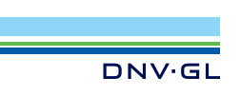
As a world-leading accreditation and certification body, DNV GL works with healthcare providers, national and regional health authorities, policymakers, payers and key stakeholders around the world. We help them develop and implement quality schemes to improve healthcare outcomes and facilitate the provision of person-centered, safe care, building on over 150 years of expertise in working with high risk industries to make them safer. From primary care to psychiatric care, from delivering precision medicine in hospitals to manufacturers of medical devices, we help our customers across the world to manage their operations and improve performance.
作为全球领先的认证和评估机构，DNV GL与世界各地的医疗机构、卫生行政部门、立法部门，支付方和关键利益相关方协作，帮助开发和实施质量管理框架从而改进其医疗管理水平。我们运用150多年来在高风险行业中所累积的专业知识，促进以人为本的安全医疗。从初级医疗到精神疾病护理，从医院的精准医疗到医疗器械的制造，我们帮助世界各地的客户管理其运营，并提升绩效。
https://www.dnvgl.com
SERO BioScience & Technology (Beijing) Co., Ltd
More than 55 years after its foundation in 1963, SERO AS has QC materials as its only production activity with extensive experience covering clinical chemistry, lipids, hormones, proteins, tumour markers, cardiac markers, diabetes, trace elements and therapeutic drugs. The SERO products hold a leading position in the Scandinavian market and are exported to more than 60 countries worldwide. By the establishment of SERO BioScience & Technology (Beijing) Co., Ltd. SERO intends to bring high quality control materials to China and contribute to the further development of the national laboratory medicine.
挪威塞若有限公司（SERO AS）自1963年成立以来，拥有超过55年的将质控品作为唯一产品的历史，其质控品经验之丰富涵盖临床化学、脂质、激素、蛋白质、肿瘤标志物、心肌标志物、糖尿病、微量元素和诊断用药等方面。SERO产品在斯堪的纳维亚市场处于领先地位并出现于世界上六十多个国家的市场上。通过SERO北京公司的的设立，SERO希望为中国带来高质量的质控品，为国家实验医学的进一步发展做出贡献。
https://www.sero.no
Dignio AS
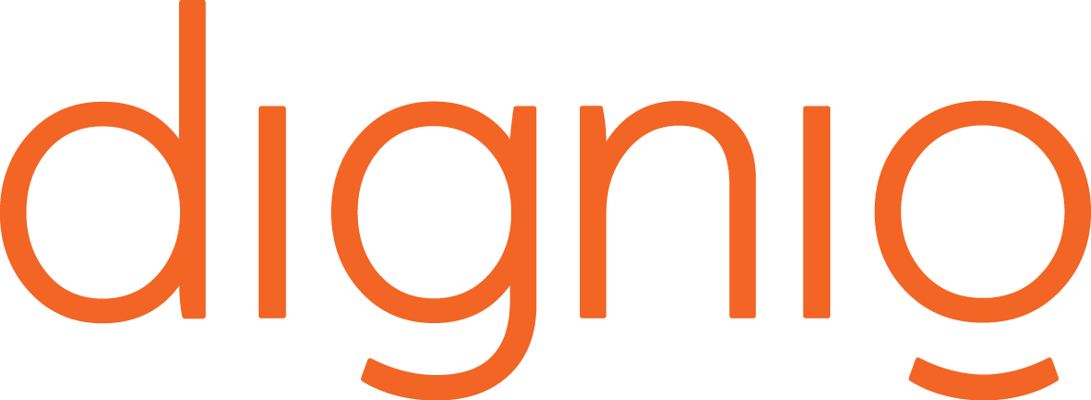
Dignio makes it possible for healthcare providers to offer a new remote care service to their patients. Our platform for connected care is patient-centric, and we believe this is the key to ensure a valuable, preventative and positive effect. With daily monitoring and continuous communication through our solutions, we enable patients to become more engaged in their own health. With our solution we allow patients to make medical measurements at home with the knowledge that healthcare professionals follow up the results and are available for support and care along the way. It provides a safe, flexible everyday life with a higher quality of life.
迪格尼奥使医疗护理能够为患者提供新的远程护理服务。我们的远程护理平台以患者为中心，我们相信这是保障有价值，有预防性和产生积极影响的关键。通过我们的解决方案进行日常监控和持续沟通，我们使患者能够更加投入自身健康。通过我们的解决方案，我们让患者在家中进行医学测量，并让医疗护理专业人员对结果进行跟踪，随时提供支持和护理。它将给您提供安全，灵活的日常生活和更高的生活品质。
https://dignio.com
Laerdal Medical
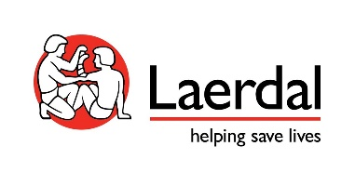
For more than 50 years, Laerdal has been dedicated to advancing research and helping implement best practices that have been shown to work. Our lifelike and durable products together with our innovative programs have prepared generations of healthcare professionals and lay responders around the world to improve patient outcomes. Our solutions are designed to develop and maintain skills, enhance clinical decision making, and cultivate communication and team training. We help build competency to ensure the impact endures over time and is sustainable in the future.
50多年来，挪度致力于推进研究，并帮助实施已被证明行之有效的最佳实践。我们高仿真且优质耐用的模拟产品，结合创新解决方案，为世界各地一代代的医护专业人员和非专业急救者提供培训，进而改善患者治疗效果——帮助拯救生命！我们的教育解决方案旨在提升和长久维持技能水平、增强临床决策能力以及培养团队沟通协作能力。我们帮助医护人员通过培训建立起能够历久弥新、并持续保持在高水准的临床胜任力。
https://www.laerdal.com/

