Registration of Norwegian Citizens in Argentina
(please fill in clearly and email to the Embassy of Norway: emb.buenosaires@mfa.no)

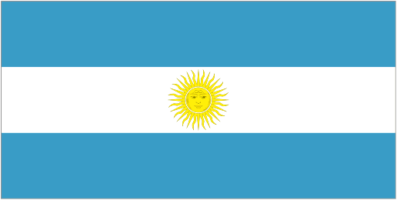 | 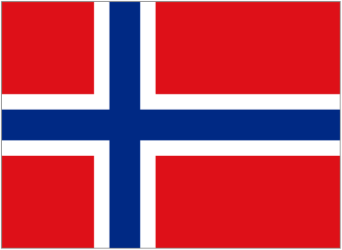 | I AM A PERMANENT RESIDENT IN ARGENTINA: □ Yes □ No  IF “NO”:  I AM STAYING IN ARGENTINA UNTIL: Month: ………… Year: …………  NB: After this date you will be removed from our Register. If you should decide to stay beyond the above date, please inform the Embassy of your new proposed date of departure so that we keep your data in our Register.
Registration date:

SURNAME |  | NAMES
Date of birth (ddmmyyyy): | Passport number: | Marital status:  □ Single □ Married □ Partner □ Widow
Address in Argentina:  Street, number, floor, flat | Postcode | City | Province
Telephone number in Argentina (please include dialling codes): |  | E-mail address (please write CLEARLY):
Mobile | Landline
Purpose of visit in Argentina:  □ Tourism □ Family visit □ Work □ Study □ Other: ……………..  ………………………… |  | If you study in Argentina, please state University and course of study: | If you work in Argentina, please state place and type of work:
Details of family travelling with you:
Full name | Relationship (wife, son, etc.) | Date of birth | Nationality
Your address in Norway:  Street, number, floor, flat | Postcode | City | Telephone number in Norway (please include dialling codes):
Contact persons in Norway:
Full name | Relationship (father, aunt, etc.) | Full address (including city) | Telephone number (please include dialling codes)
Would you like to receive general information about the Embassy of Norway or about events organised by the Embassy while you are in Argentina, Bolivia, Paraguay and Uruguay? |  |  | □ Yes □ No
Would you authorise the Embassy to give your email address to other Norwegians who wish to meet informally while in Argentina, Bolivia, Paraguay and Uruguay? |  |  | □ Yes □ No
Any remarks or circumstances that you wish to bring to the attention of the Embassy:

