ROYAL NORWEGIAN EMBASSY IN ZAGREB
CROATIA
TENDER INVITATION
Facility Management Services
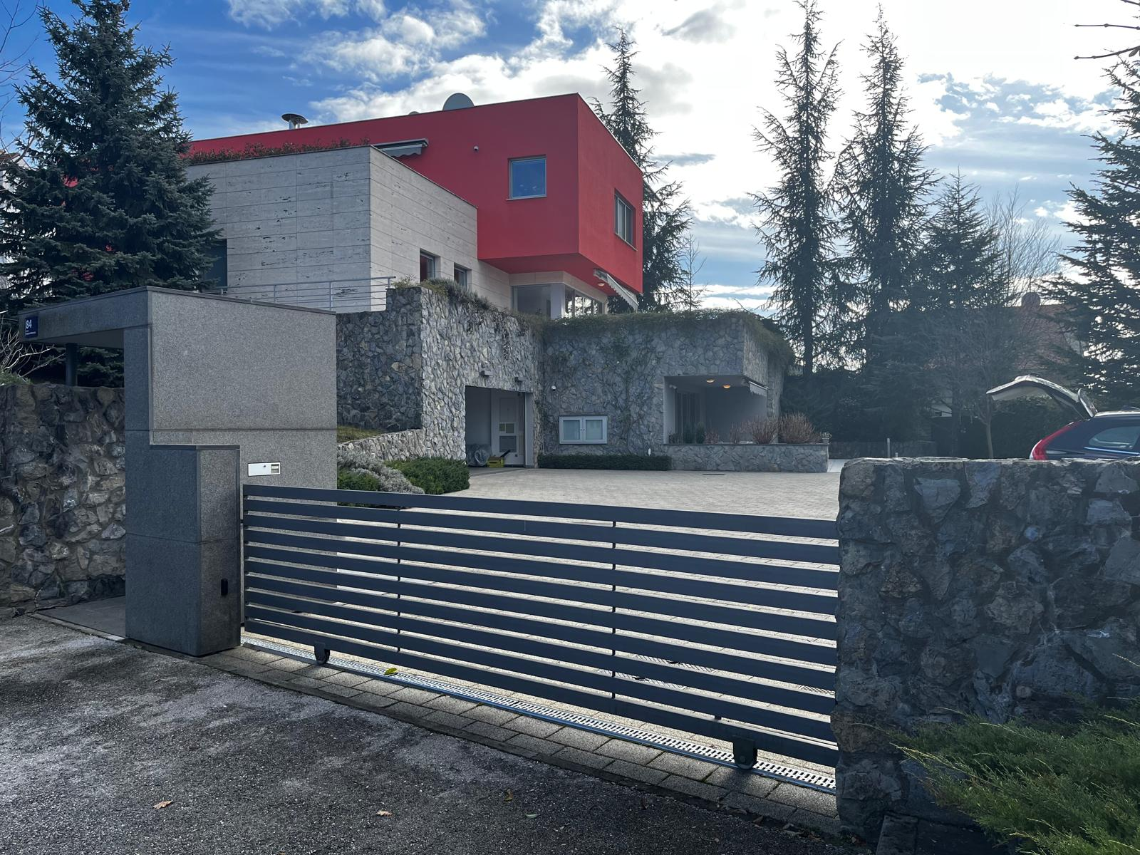

The Norwegian residence in Zagreb

March 2025

I – INVITATION AND GENERAL INFORMATION
- Invitation
The Royal Norwegian Embassy in Zagreb (the client) invites you to participate in a tender competition for the award of the contract for facility management services in Zagreb, Republic of Croatia.
The terms and description of the assignment are described in the tender documents:
- Tender invitation
- Price summary form – Annex 1
- Code of conduct – Annex 2
We ask potential bidders to notify the Embassy if anything contained in the tender document’s conflicts with common norms or generally accepted practices in Croatia. It is important that we receive such information well before the bid submission deadline to make the appropriate adjustments in the tender documents and/or extend the bid submission deadline. Similarly, we ask the bidders to inform the Embassy about contractual terms they want to add well before the bid submission deadline.
The contract language shall be English.

- Scope of work

The residence of the Royal Norwegian Embassy in Zagreb is located at Baboniceva 84, 10000 Zagreb. The total gross area of the residence is approximately 400 m2. The residence consists of;
- a basement with a kitchen, two rooms, a technical room, a storages and garage.
- a ground floor with an entry hall, library, living room, dining room, bathroom and kitchen.
- a first floor/private area with 3 bedrooms, living room and bathroom.
- an open swimming pool with the size of 35 m2
- a front yard and backyard with the size of 1300 m2

The technical systems installed at the residence include:

- HVAC. (Heating, ventilation and air condition)
- Technical systems for cleaning and heating of the pools.
- Irrigation and drainage installations.
- Elevator (serviced by approved company)
- Video surveillance (serviced by approved company)
- Electric gate and doors

We are searching for a local firm who can provide a range of miscellaneous facility management services at the residence. Example of possible maintenance services are including, but not limited to plumbing, electrical, maintenance of the façade and roof, carpentry, insulation work, maintenance of technical equipment and outdoor, pool maintenance and weekly cleaning (approx. 8 hours/1 day a week).
The contractor will present a planned program and submit an offer for preventive maintenance attached to the bid. The planned program for preventive maintenance and the price will be a subject for discussion and negotiation.
Project management for smaller works may also be relevant for this agreement but agreed upon in advance if found necessary by the client.
The contractor also guarantees to perform emergency interventions on the building and all its technical installations and equipment after calls from the Embassy confirmed by e-mail, following this procedure:
- for problems caused by water casualties or from heating or cooling system; within three hours from the emergency call
- for problems caused by malfunction of the general electric system; within three hours from the emergency call
- for other kinds of breakdowns; the following working day

The timeframe of the facility management contract will be 1 year, with possible extension of 1+1+1 years. Potentially a total of four years. Both parties can terminate the contract with 60 days written notification.
The Embassy is authorised to make decisions regarding the work, including decision with financial consequences.
The timeline and budget will be agreed before each assignments starts, if they are not a part of the periodic works renumerated with a fixed price and schedule. The facility management company will send a short written report after each assignment is completed.

- Qualification criteria and award criteria
The Embassy will select the tender that is most advantageous both economically and in terms of quality and price, based on the following criteria:
The following qualification criteria apply to the facility management company:
Criteria | Documentation
The company must have a solid financial position  The company has experience from similar assignments, including requirements to meet local laws and regulations.  Should have experience from projects with international clients. | - The Company shall provide the Embassy with documentation demonstrating its financial standing, including but not limited to:  - Annual financial statements (GFI-POD) filed with FINA,  - Auditor’s report (if applicable),  - Tax clearance certificate confirming compliance with tax obligations,  - A description of previous assignments

Award criteria
Criteria | Documentation
Price | Completed and signed price summary form.
Competence of assigned local Contact person/ Site manager/Facility manager on site, including relevant experience.  Fluency in English and Croatian, both written and spoken | CV (education and general work experience):  Descriptions of 1-2 assignments in which the designated person worked as Contact person/ Site manager/Facility manager on site. These descriptions should include:  - Address of building  - Client  - Size (square meters) and total cost of renovation project  - Contract value of bidder’s assignment within the renovation project.  - Commencement and completion year of the assignment (if not completed, inform about the status of the assignment).  - A short description of the functions the designated person had in the assignment.  The Embassy might carry out an interview for a further assessment of relevant competence and understanding of the assignment, including proficiency in English and Croatian.

The language of the bid must be English.

- Additional information
If supplementary information is required, the Embassy shall be addressed in writing, preferably no later than 5 days prior to the bid submission date, to vanja.hrzic@mfa.noII – SERVICES AND CONTRACT TERMS

- contract TERMS

1.1 The principal terms
The principal terms of the contract will be those contained in the tender documents, supplemented by relevant Croatian laws and regulations as well as generally accepted norms for the execution of facility management services.
The Facility Management company will have sole responsibility for the assignment being adequately executed. All specialized companies assisting the Facility Management Company in fulfilling the assignment are to be considered as sub-consultants.
The contractor will communicate ID and function of each worker or technician appointed in each type of work, trying as far as possible to use the same personnel each time. All works must be easily identified by personal badge with pictures, as per norms.
1.2 Health, safety, and work environment (HSE)
The facility management company are responsible for health and safety issues at the property according to local rules, and shall make sure that all HSE regulation is being followed (the list is not comprehensive):
- Work area cleanliness
- Wearing of safety equipment
- Storage of dangerous materials
- Compliances with adequate procedures for risky work operations
- Total amount of work hours on site
- Incidents and/or accidents (serious incidents/accidents are to be reported immediately)
- Initiatives taken to prevent incidents/accidents
- Information given to the workers in this matter

In case of hazardous work, the facility management company shall work out a HSE plan based before conducting the work. The HSE plan shall be obliged to comply with the local regulations and to be approved by the Embassy before conducting any kind of hazardous work.
1.3 Confidentiality and media contact
No contracting parties shall make comments regarding this agreement or other matters concerning Embassy’s affaires to the newspapers, radio, television or other without Embassy’s consent.
1.4 Materials
All materials are to be approved by the Client before proceeding to order and install materials on site. It shall be the facility management company’s obligation to ensure that works carried out by the contractor do fit for their purpose.
1.5 Reports and meetings
The contractor shall provide a quarterly report in the end of December, March, June, and September. The report shall include:
- a description of work carried out the previous three months including pictures
- a description of emergency calls including pictures
- the state of the equipment and possible forecast defects or malfunctions
- reparation proposals

Teams meetings with the client are to be held when needed.

- Hourly rate, BUDGET, and payment

2.1 Secondary Expenses

All expenses, including overhead cost, administration of the assignment, and travel costs related to the performance of the assignment shall be included in the hourly rate (for additional works) and fixed rate. The parties will agree in advance in writing about the extent to which the facility management company can invoice travel time related to the assignment and additional works.
  - Budget

The scope and budget for the work must be agreed for each assignment for additional works. The agreed budget for each such assignment will be considered as a fixed-price fee.
2.3 Additional work
If the facility management company is asked to carry out work which is clearly not within the agreed scope of work in each assignment, such work shall be considered additional work and the agreed hourly rate given in the price summery form applies.

Whenever the facility management company considers it necessary to carry out work, which is not covered in the assignment, The Embassy shall receive written notice without undue delay. Whenever such notice is not given, the facility management company shall forfeit his right to claim extra fee for his work, unless it should be obvious to Embassy that the work is not included in the assignment.
2.4 Payment
Payment of the agreed price offer for each assignment shall take place in installments according to an agreed payments schedule. The schedule shall clearly define the correlation between payments and the master time schedule. Any deviation from the planned progress shall be reflected by a corresponding change in the payments schedule. Apart from the amount to be paid, each invoice shall state the agreed total price and each previous payment. Invoices will be paid within 30 days of receipt.
  - Insurance

The facility management company shall have an adequate liability insurance coverage.
A copy of the insurance policy shall be handed over to the Embassy prior to the contract signing.
  - The embassy’s obligations and performance coordination

The Embassy will from signing the contract allow access to the building for normal maintenance service in the following hours: 09:00 – 12:00 h, Monday to Friday. The execution of the present contract shall as far as possible not interfere with the normal use of the building. Day and time of the execution of the works shall be agreed upon up front each time.
  - Disputes

Any dispute related to the assignment shall be resolved based on the contract between the parties supplemented by applicable Croatian law.
Unresolved disputes shall be referred to the court having jurisdiction over the property.
The legal entity on Embassy’s side is the Kingdom of Norway, represented by the Embassy. No individual representing the Norwegian Embassy in Zagreb can be personally sued under this contract or in any other context associated with the project.

III - THE TENDER PROCEDURE

The tender procedure will be carried out in a manner as to ensure fair and equal treatment of all bidders, complying with the European requirements regarding public procurements. Conversely, the bidders shall not by the way of common arrangement, co-ordination, or similar steps, try to influence the outcome of the tender procedure.

The enclosed supplier’s code of conduct must be signed and submitted together with the bid. The absence of a signed supplier code of conduct might lead to rejection of the tender.

The Embassy reserves the right to carry out a company review (due diligence) on the companies participating in the competition.

The Embassy may choose to reject all tenders. If all tenders are rejected the Client shall without undue delay inform the tenderers accordingly.

IV - THE BID (TENDER)
The bid is to be sent by email to emb.zagreb@mfa.no including PDFs of the price summary form (Annex 1) completed and signed, and a signed code of responsible business (Annex 2).

The bid should be marked with “The Royal Norwegian Embassy in Zagreb – Facility Management Contract”.

The bids must reach the abovementioned email address no later than 15.04.2025. Late bids will not be considered.

Bids should not expire before 15.07.2025.

Zagreb, 28.03.2025.

Norwegian Embassy

