Support to the judiciary in Bosnia and Herzegovina – strengthening prosecutors in the criminal justice system (Joint funding from Norway and Switzerland)
Total funding: NOK 36 million (approximately € 3 976 875)
Start date: December 2014
End date: December 2018
Implementing partner: High Judicial and Prosecutorial Council of Bosnia and Herzegovina (HJPC)

The challenges
The judiciary in Bosnia and Herzegovina faces many challenges. This is partly due to the complicated administrative and legal organisation of the country.
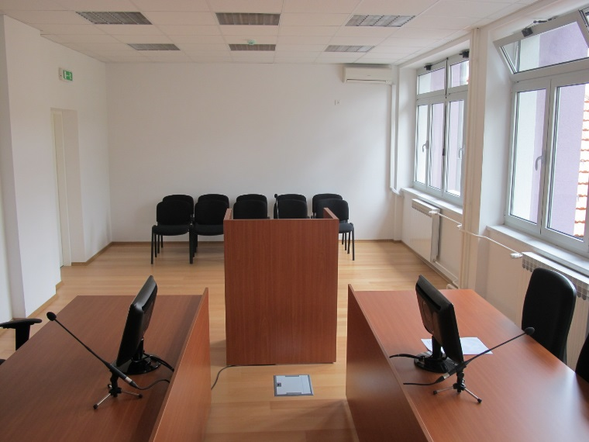
Since the end of the 1990’s, Norway has supported projects to reform the judiciary in Bosnia and Herzegovina. Since the establishment of the High Judicial and Prosecutorial Council of Bosnia and Herzegovina (HJPC) in 2004, a large part of the funding has been channeled through this institution. The HJPC is an autonomous organ, which shall ensure an independent, impartial and professional judiciary. The HJPC is also responsible for providing a professional and efficient court and prosecutorial system.

Description of the project
The project has three overall objectives: to improve the efficiency and quality of prosecutor’s work; to enhance management and coordination within the prosecutorial system; and to improve prosecutorial service delivery to citizens.
Modrica Court.
The project seeks to support the relevant national authorities – the HJPC, its’ Prosecutorial Strategic Body, and Chief Prosecutors, in driving forward a reform process within the prosecutorial system which will result in improved performance, efficiency and credibility.
More information about the HJPC: http://vsts.pravosudje.ba/

