Norwegian support to improving judicial efficiency
Project snapshot
Total funding: NOK 17,2 million (approximately € 1,907,487)
Start date: September 2015
End date: Fall 2018
Implementing partner: High Judicial and Prosecutorial Council of Bosnia and Herzegovina (HJPC)
The challenges
The judiciary in Bosnia and Herzegovina faces many challenges. This is partly due to the complicated administrative and legal organisation of the country.
Since the end of the 1990’s, Norway has supported projects to reform the judiciary in Bosnia and Herzegovina. Since the establishment of the High Judicial and Prosecutorial Council of Bosnia and Herzegovina (HJPC) in 2004, the funding has been channeled through this institution. The HJPC is an autonomous body, which shall ensure an independent, impartial and professional judiciary. The HJPC is also responsible for providing a professional and efficient court system.
Description of the project
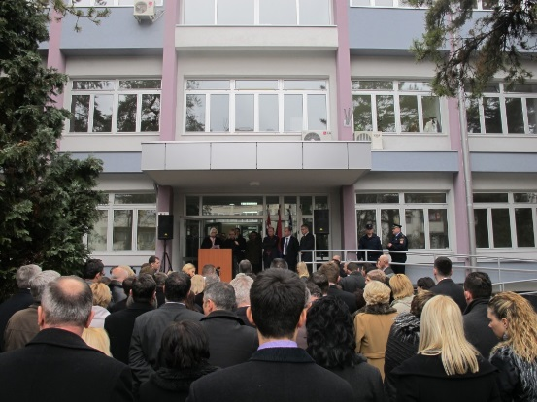
This is the second phase of a project started in 2011 - aimed at improving judicial efficiency. The project shall:
- Improve the processing of small claims, including the collection of unpaid utility bills
Equip more courts with ICT-equipment allowing them to use a specialized electronic case-handling system (SOKOP).
- Refurbish and equip court buildings, e.g. in Tuzla.
- Improve the management of courts
Training, develop system for the evaluation of judges etc.
Ambassador Lilloe giving a speech during the opening of the renovated Modrica Court.

- Enhance the use of out of court settlement/mediation
Run public information campaigns about the possibilities offered by alternative dispute resolutions, organisation of “dispute resolutions week”, etc.
- Increase public knowledge of the work of the judiciary
Develop communication strategy of the courts, media training etc.
Part of the project will be carried out together with the Norwegian Courts Administration (NCA) and the Netherland’s Council of the Judiciary to see how to improve the management of courts.
More information about the HJPC: http://vsts.pravosudje.ba/
NCA: http://www.domstol.no/en/National-Courts-Administration/
Netherland’s Council of the Judiciary: https://www.rechtspraak.nl/english/the-council-for-the-judiciary/pages/default.aspx
Agreement NMFA-HJPC:

