Norwegian support to more transparent recruitment of judges and prosecutors
Project snapshot
Total funding: NOK 3 million (approximately € 343,324)
Start date: September 2015
End date: Fall 2017
Implementing partner: High Judicial and Prosecutorial Council of Bosnia and Herzegovina (HJPC)

The challenges
The judiciary in Bosnia and Herzegovina faces many challenges. This is partly due to the complicated administrative and legal organisation of the country.
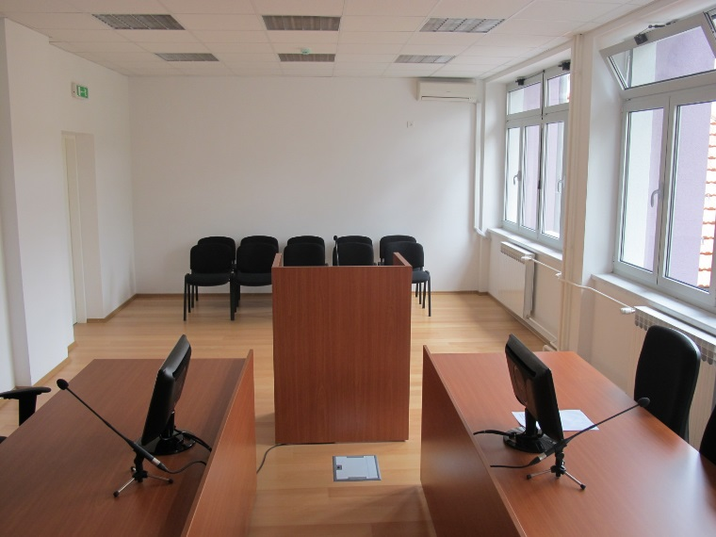
Since the end of the 1990’s, Norway has supported projects to reform the judiciary in Bosnia and Herzegovina. Since the establishment of the High Judicial and Prosecutorial Council of Bosnia and Herzegovina (HJPC) in 2004, the funding has been channeled through this institution. The HJPC is an autonomous organ, which shall ensure an independent, impartial and professional judiciary. The HJPC is also responsible for providing a professional and efficient court and prosecutorial system.

Description of the project
The project shall improve the system of recruitment to the judiciary. Candidates for the position of judge or prosecutor must sit for electronic entry exams. Currently, the test is offered only in Sarajevo. This project will equip additional three testing-facilities allowing for a swifter process. Through this project, the HJPC will also improve other parts of the recruitment process (use of video-conferences for interviews etc).
Newly renovated Modrica Court.
More information about the HJPC: http://vsts.pravosudje.ba/
NCA: http://www.domstol.no/en/National-Courts-Administration/
Netherland’s Council of the Judiciary: https://www.rechtspraak.nl/english/the-council-for-the-judiciary/pages/default.aspx
Agreement NMFA-HJPC:

